**Appendix 4**

**Test results for running 50,000 time steps with a public goods cost of 0.0001**

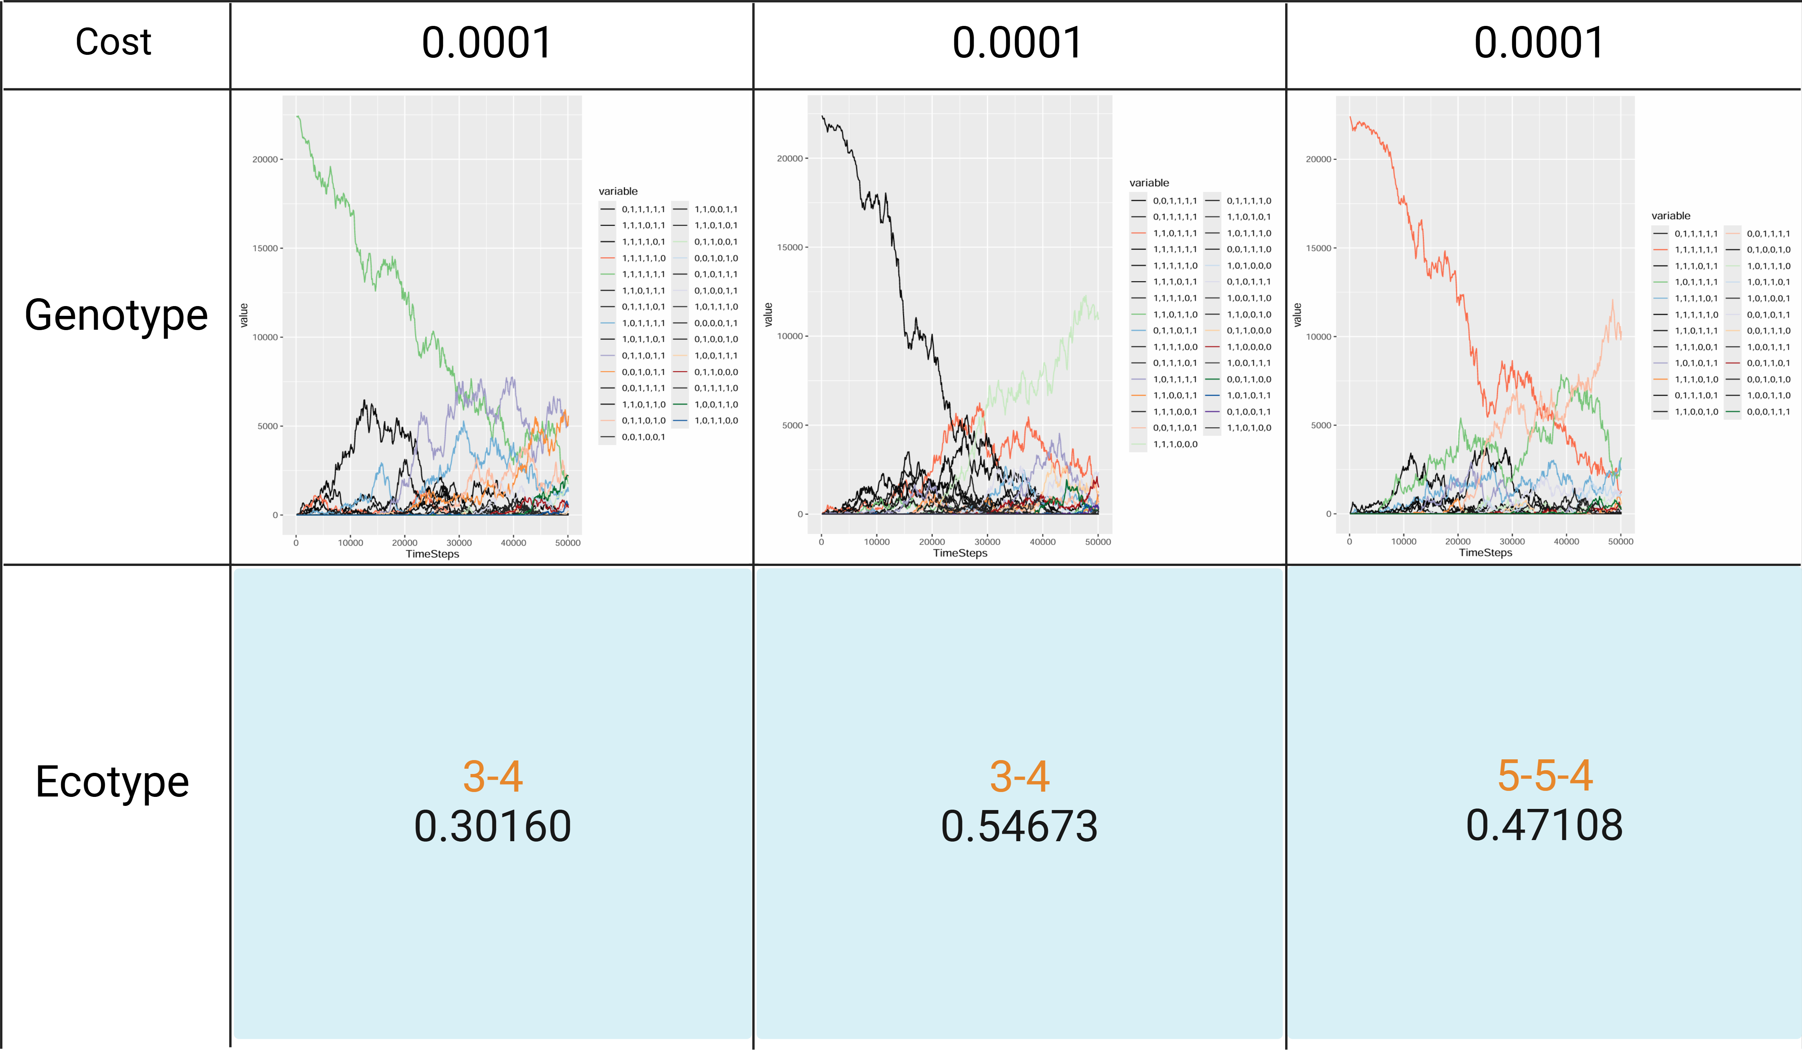

The genotype changes when the public goods cost is 0.0001, and the ecotype composition at the 50,000th time step. The parameter combination is "cost = 0.0001", " public goods production interval = 1 ", "public goods diffusion interval = 1", and " public goods decay rates = 0". The removal threshold for the number of genotypes were genotypes with a proportion less than 1.